**Exercise- 12**

**Step 1: First create a folder named** bloggerapp .

**Step 2: Now in the terminal write the location of your folder and then write “npx create-react-app .” in your terminal.**

**Step 3: Now write ‘npm start’ in the terminal, this will open your react app in the browser.**

**Step 4: Set up the Folder Structure:**

**Inside src ->**

* **Create components folder and make the following files in it:**
* **CourseDetails.js**
* **BookDetails.js**
* **BlogDetails.js**

**Step 5: Codes for the files:**

* **CourseDetails.js :**

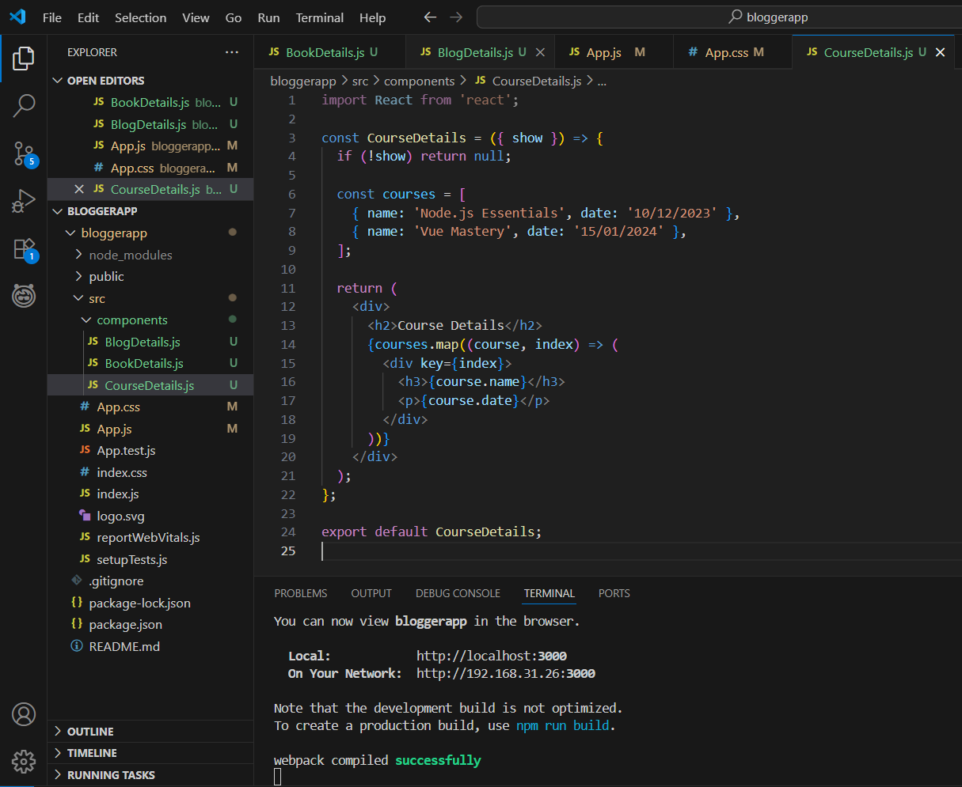

* **BookDetails.js :**

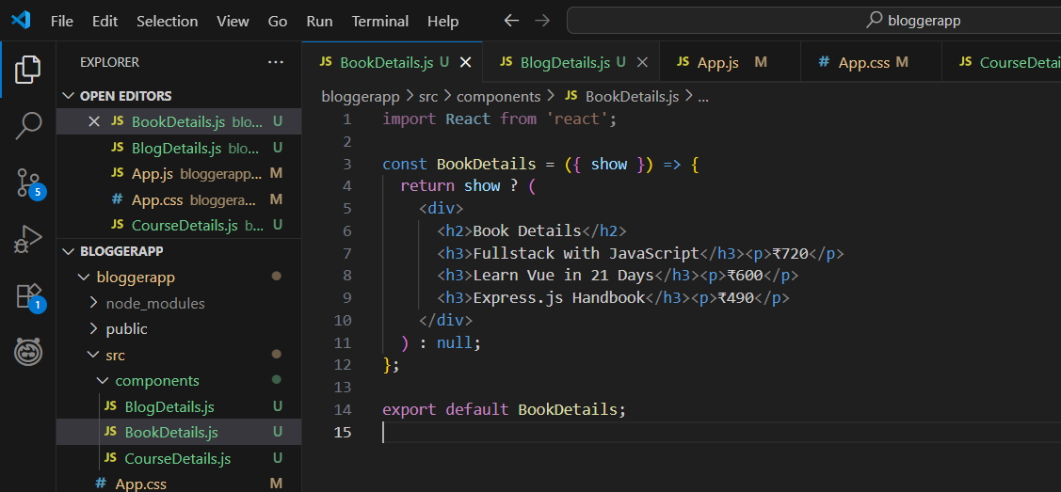

* **BlogDetails.js**

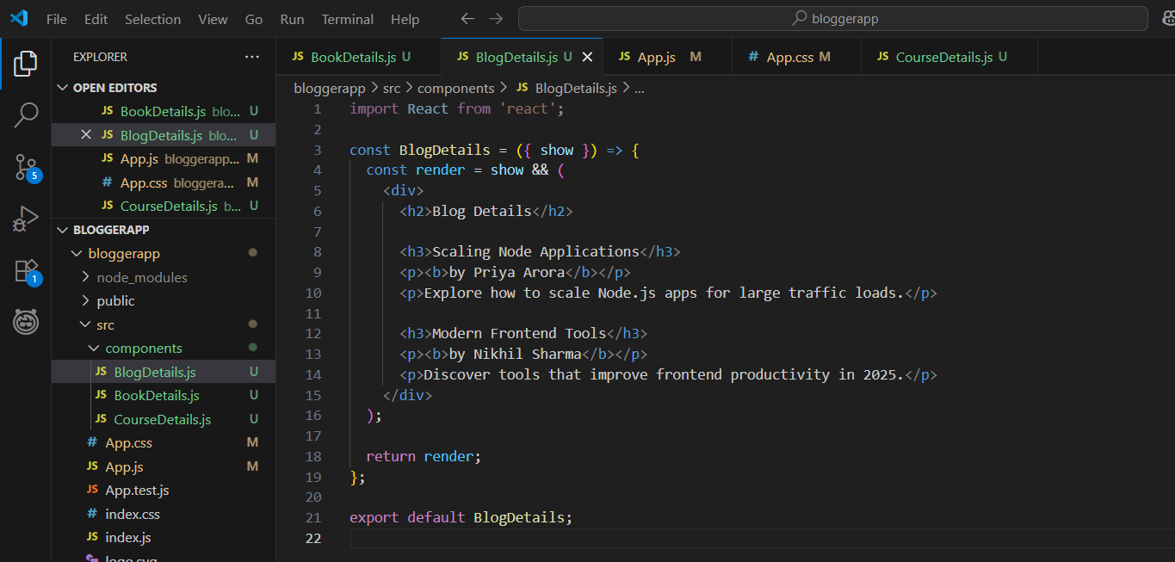

**Step 6: Changes in the existing code files:**

* **App.js**

import React, { useState } from 'react';

import './App.css';

import CourseDetails from './components/CourseDetails';

import BookDetails from './components/BookDetails';

import BlogDetails from './components/BlogDetails';

function App() {

  const [visibleSection, setVisibleSection] = useState('all');

  return (

    <div className="App">

      <div className="controls">

        <button onClick={() => setVisibleSection('all')}>Show All</button>

        <button onClick={() => setVisibleSection('courses')}>Courses Only</button>

        <button onClick={() => setVisibleSection('books')}>Books Only</button>

        <button onClick={() => setVisibleSection('blogs')}>Blogs Only</button>

      </div>

      <div className="sections">

        <div className="box"><CourseDetails show={visibleSection === 'all' || visibleSection === 'courses'} /></div>

        <div className="box"><BookDetails show={visibleSection === 'all' || visibleSection === 'books'} /></div>

        <div className="box"><BlogDetails show={visibleSection === 'all' || visibleSection === 'blogs'} /></div>

      </div>

    </div>

  );

}

export default App;

* **App.css**

.App {

  font-family: Arial;

  padding: 20px;

  text-align: center;

}

.controls button {

  margin: 0 5px;

  padding: 10px 15px;

  font-weight: bold;

  cursor: pointer;

}

.sections {

  display: flex;

  justify-content: space-around;

  margin-top: 30px;

}

.box {

  border-left: 4px solid green;

  padding-left: 20px;

  text-align: left;

  min-width: 250px;

}

**OUTPUT:**

* **Show All :**

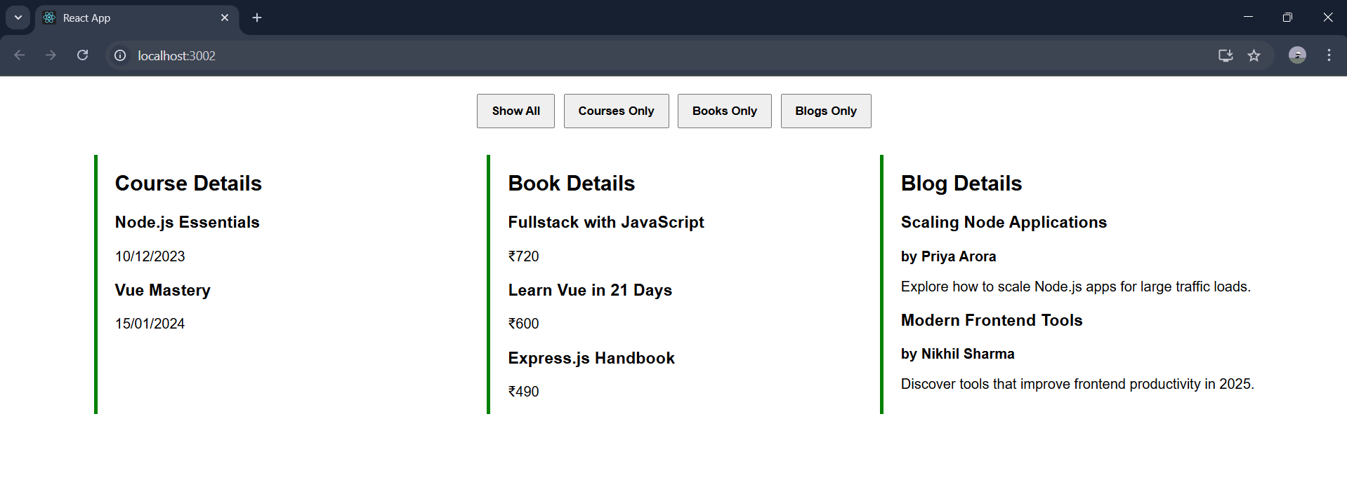

* **Courses Only :**

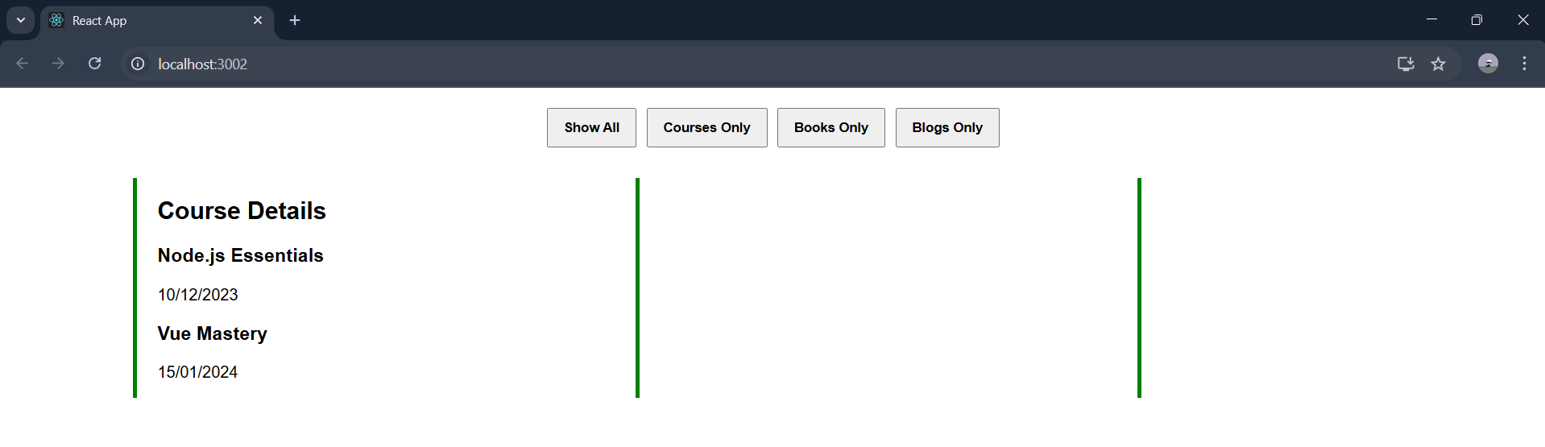

* **Books Only :**

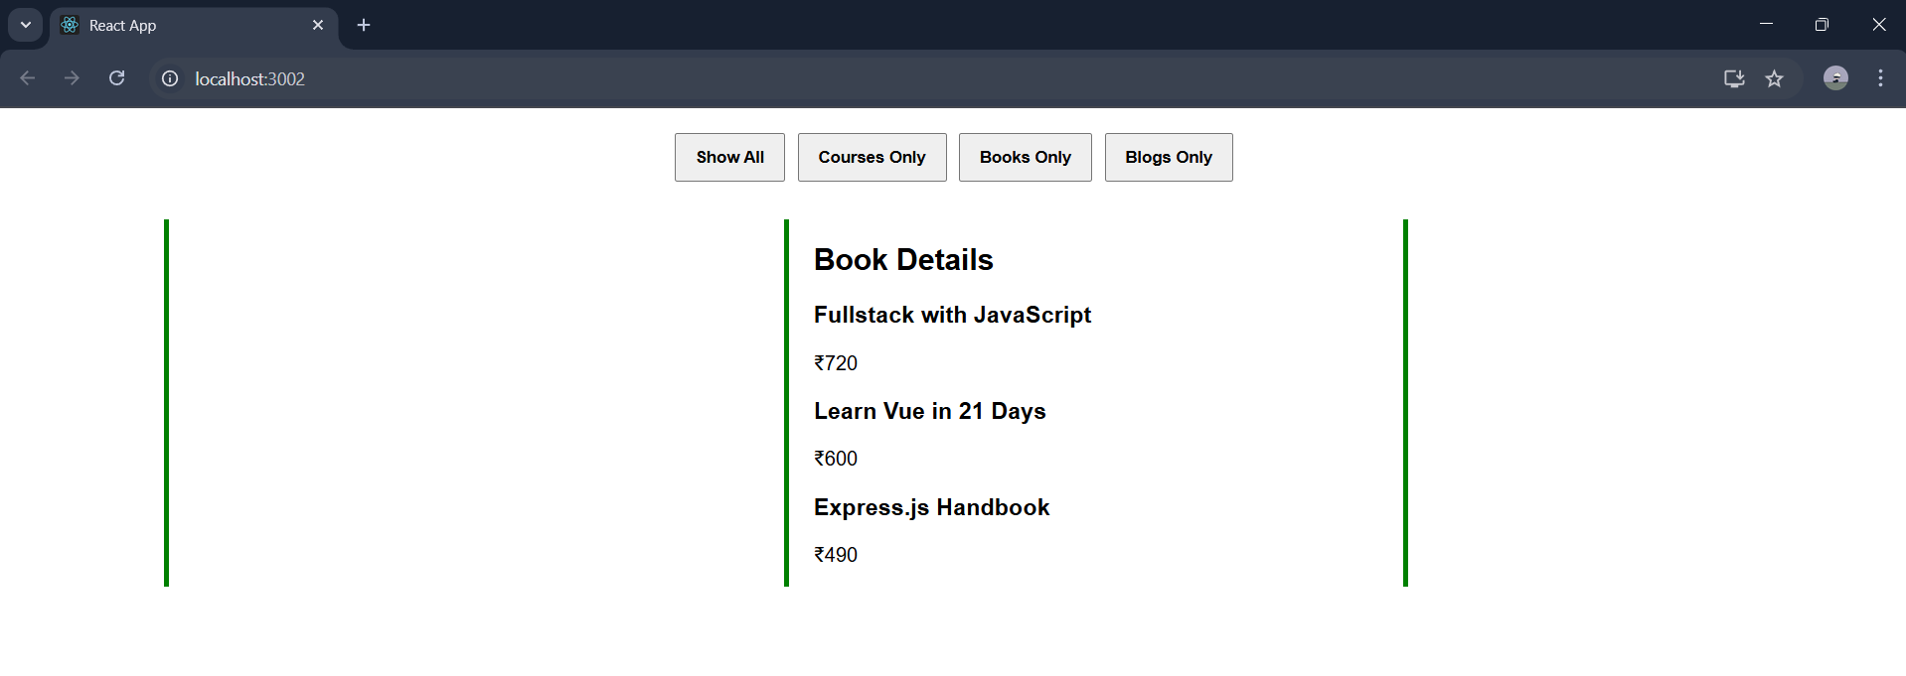

* **Blog Details :**

